Belgrade, 04.07.2011.

Evaluation of the Academic Day of the Belgrade University,
Faculty of Philosophy, 11.06.2011

This is a short summary of the results of the evaluation questionnaire of the Academic day within the DASUN project, held on 11.06.2011. Faculty of Philosophy in Belgrade, Serbia. The questionnaire was completed by participants on the Academic day of the University. The concept of Academic day included an introduction and presentation of the DASUN project, two presentations about education and learning in the third age, as well as four workshops of four study groups of the Faculty of Philosophy: ethnology and anthropology, art history, archeology and history. Results of the questionnaire can be seen below.
From a total sum of 55 completed questionnaires, 52 are valid. The first two questions in the questionnaire concerned the general impression of the participants on the Academic day, and the next two - on their satisfaction with teaching in the first part of the Academic day. On these four questions, which we explained below, participants had the opportunity to choose one of the following answers:
- "It was very interesting and inspiring"
- "I liked it"
- "Not everything was interesting and inspiring"
- "Other".
As the questionnaire was originally taken from the German Institute for general scientific continuing education (ZAWiW) at the University of Ulm, these answers are not rated by categories from the most positive to the most negative answer, but the first answer involves a cognitive aspect, ie. what participants considered as useful and significant at the cognitive level; the second answer refers to the emotional dimension, while the third indicates that the participants' cognitive aspect has not been fully realized. This means that the answer "I liked it" isn't lower in intensity of answer " It was very interesting and inspiring", but these two responses indicate different dimensions of their attitude examined. The answer "Other" provides the possibility for participants to add a response which is not covered by the previous categories, but describes their impression of the aforementioned aspects of the Academic Day the best.
So, for the question about the impression taken with the first Academic day, we got positive answers: 59.6% of them answered they were very interesting and inspiring, 38.5% said they liked the Day, while one respondent said that he did not expect this day to be so interesting. These results can be seen in the graph below. On a similar question about the form and the concept of classes and workshops all the answers were also positive: 44.2% of them said they were very interesting and inspiring, 51.9% of them reported they liked this aspect, and two respondents under "Other" also reported positive comments.
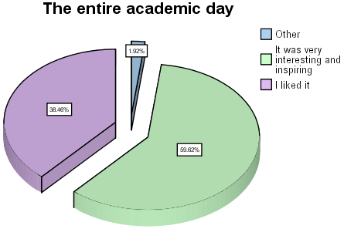
* Chart 1: Impression about the first Academic day
Considering presentation of mr Zorica Milosevic on "Ageing and Society - Concepts and experiences of education for the elderly in Europe", 36.5% of respondents said they found this presentation very interesting and inspiring, 57.7% of them said they liked it , while 5.8% said that not everything was interesting and inspiring. Considering presentation of dr Ljiljana Levkov on "Why learn – Psychology of adulthood and aging", 53.8% of respondents said they found this presentation very interesting and inspiring, 25% said that they liked it, while 3.8% of them said that not everything was interesting and inspiring. 17.3% of respondents chose the answer "Other" and wrote positive answers, such as "Excellent", "Great," "It is instructive, interesting and cheerful", etc.
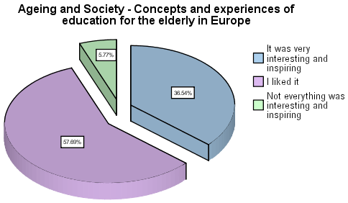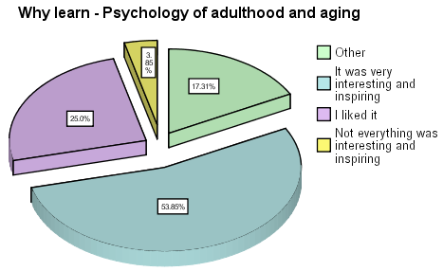
* Chart 2: * Chart 3:
Presentation of Mr Zorica Milosevic Presentation of Dr Ljiljana Levkov
The following are open questions, for which we will mention only the most interesting responses and suggestions. Asked about the comments on the topic of the entire Academic, participants mentioned they were sorry because all the workshops were organized at the same time, so they could not listen to all of them. Most of them said that they liked the way the academic day was designed and implemented, as well as topics that were discussed. At one of the participants also appeared a slight skepticism regarding further implementation of this program, but most of them are very grateful for the opportunity to attend this event. Topics were very attractive for participants, considering the Danube as the central theme, but they suggest that the next could be something more practical oriented.
When it comes to proposals for the upcoming lectures and workshops in the Academic day, 15.4% of participants stated that the workshop should be organized at different times, in order to attend many of them, which tells us about their interest in all topics of this year's Academic day. Their proposal is to organize Academic days in the future, or even Academic weeks, and to expand the Academic day to other faculties of the University, which is part of a plan for future activities in this field. It is obvious that there is a need to organize such events more often, but that all topics are equally accessible to the participants, so they are not forced to choose only one of several workshops that interest them. In addition, considering that participants liked the workshop as a way of studying, they are interested in some detailed and practical topics, in which they can still take an active part.
We asked the participants about the scientific fields of other faculties of Belgrade's University they are interested in, and we got the following answer:
Economy | Astronomy
Faculty of Organizational Sciences | Genetics
Geography | Fine arts
Agronomy | Film art
Computers | Biology
Banking Services | Music and Ethno music
Literature and Language Studies | Legal sciences
History of science | Architecture
Medicine and Health | Faculty of Security

As you can see, there is a whole collage of interests of participants in various fields of Belgrade's University has to offer. Interests equally apply to the natural and social sciences, which opens up space for new content and themes that could be included in the next Academic day. It directs us to begin next steps with some of these proposals.
When we asked "How can we attract and invite the students for the next Academic day?", participants offered suggestions to us. 38.5% of participants said that the publicity should be more familiar with the program of the Academic Day through the media, whether it comes by radio, television or printed media. In addition, they proposed forwarding the information to potential participants through various associations and organizations of pensioners by posters that would stand in hospitals, clinics, community centers and nursing homes, and to organize presentations in different ways. Certainly we do not doubt that the participants of the Academic Day will verbally transfer positive impressions to their friends.
We mentioned that the participants could choose between four workshops organized by representatives of four departments of the Faculty of Philosophy. In completing the questionnaire they could also choose among the last four questions – those related to the workshop attended. These questions consist of two parts: for the first part of the question participants chose one of four answers, which we mentioned in the first issue ("It was very interesting and inspiring", "I liked it", "Not everything was interesting and inspiring" and "Other"). The second part of the question refers to the assessment of the extent to which participants have met their expectations in this workshop, and offered answers were:
- "They are completely satisfied"
- "They are partly satisfied"
- "They are not at all satisfied".
These answers already tell us about a certain level of participants' expectations achieved. There was some space left for the reasons, if some of them wants to write it. The following charts represent these results:
- Workshop of the Department of Ethnology and Anthropology, with a topic "Serbian folk religion, mythology and demonology of water", of dr Danijel Sinani
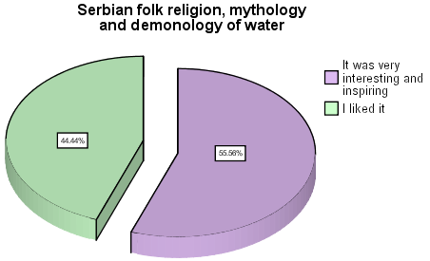
* Chart 4: Workshop of dr Danijel Sinani
This workshop was attended by 34.6% of the participants of the Academic day. As we can see in the chart no. 4, 44.4% of the participants of the workshop said that it was very inspiring and interesting, and 55.6% said that they liked it. All participants, therefore, gave a positive evaluation for this workshop. For question whether the workshop met their expectations, all participants answered that the workshop fully meet their expectations and interests.
- Workshop of the Department of Art history, with a topic "The portraits of the two rulers of Belgrade in the middle ages", of Mr Dragana Pavlovic
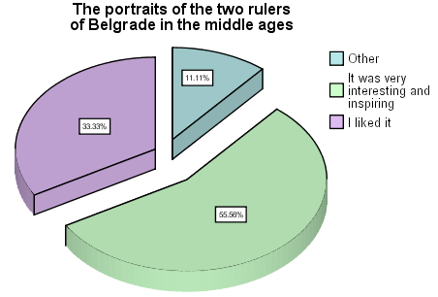
* Chart 5: Workshop of Mr Dragana Pavlovic
This workshop was attended by 17.3% of participants on the Academic day and they all gave positive marks: 55.6% of the participants of the workshop said that it was very inspiring and interesting, and 33.3% said that they liked it. Within the answer "Other" they stated: "It's very interesting, you should take the whole morning." When asked whether the workshop met their expectations, 15.3% of participants answered that the workshop fully meet their expectations and interests, while 1.9% said that their expectations were partially met.
- Workshop of the Department of Archeology, with a topic "Roman heritage on the Danube", of Mr Stasa Babic
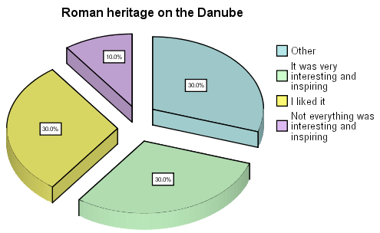
* Chart 6: Workshop of Mr Stasa Babic
This workshop was attended by 19.2% of the participants of the Academic day. In the chart above we can see their answers about general impression of the workshop: 30% of the participants said that they liked it, 30% also said that they were very inspired and interested, while 10% of them felt that not everything was inspiring and interesting. Within the answer "Other" they listed: "I felt great. Stasa is smart, beautiful and interesting", "Delighted with the way teacher presented" and "Very dynamic, with lots of data." When asked whether the workshop met their expectations, 13.4% of participants answered that it fully met their expectations and interests, and 5.7% said that their expectations are partially satisfied.
- Workshop of the Department of History, with a topic "Serbian capitals on the Danube – Belgrade and Smederevo in the 15. century", of dr Marko Suica
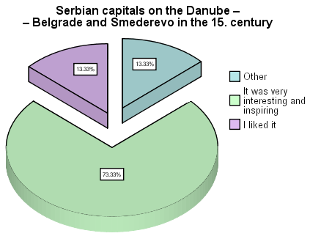
* Chart 7: Workshop of Dr Marko Suica
This workshop was attended by 28.8% of the participants of the Academic day. Here we also found positive comments: 13.3% of participants said that they liked the workshop, and 73.3% of them said that this workshop was very interesting and inspiring for them. Within the answer "Other" they stated: "It was great" and "Extraordinary." When asked whether the workshop met their expectations, all participants responded that the workshop fully meet their expectations and interests.
As we have seen, Academic day met very positive comments and enthusiasm of those who participated in it. What we also found out from them, which is very important to us, is that the participants would like to see these ideas and concepts of the Academic day the next year also and that it should be extended to two or more days. Of course, all the data we received from this questionnaire open the space for further action, as well as ideas that can be successfully implemented, both in Serbia and in the countries - partners in the DASUN project.

